Instruction:

Complete all questions in 2 hour.

1. Von Neumann Simulator. This program simulates a very simple computer with the von Neumann architecture.
   1. Download the von Neumann Simulator (VonNeumann.exe) program from google classroom Week 5 folder. Save it in your Documents folder and run it. You will see a window similar to this:

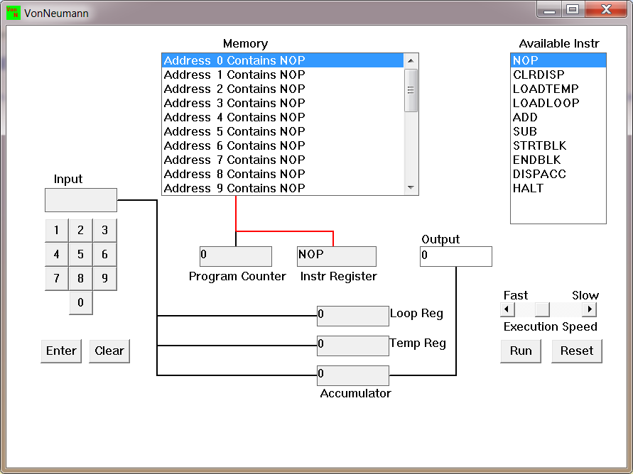

The simulator has a small program memory area which is available for programming. To enter your program instructions simply click on the “Available” instruction on the list on the right and then click on the “Memory” location you wish to put it in.

This simulator understands only the following ten instructions:

|  |  |
| --- | --- |
| NOP | No Operation, i.e. do nothing. |
| LOADTEMP | Get a number from the keypad, completed by the Enter key, into the Temporary Register. |
| LOADLOOP | Get a number from the keypad, completed by the Enter key, into the Loop Register. |
| CLRDISP | Clear the Display. |
| ADD | Add the Temporary Register to the Accumulator |
| SUB | Subtract the Temporary Register from the Accumulator |
| DISPACC | Display the contents of the Accumulator |
| STRTBLK | Start of Loop Block |
| ENDBLK | End of Loop Block |
| HALT | Halt. Stop Program |

* 1. Load the following program in the memory and explain what does the program does?

LOADTEMP: The following functions allows user to enter or load the data into the Log register/ or circuit.

ADD: It returns the sum of values entered. At first it sums the data to 0 then adds the loaded data to the stored value of Accumulator.

LOADTEMP: It loads the data to the circuit.

ADD

DISPAAC: it displays the output of the operation.

HALT: It stops the operation.

Ans:

The program sums two of the entered number and displays the output in the output box and stops. In this following program proceeded in the following manner operation:

Step1: Asked user for input and input entered 7

Step 2: It added value to the accumulator value (0) and stored it in accumulator

Step3: Asked for input and input entered 7

Step4: it added value to the accumulator value (7) and stored it in accumulator (14)

Step5: it displayed the output to the user.

Step 6: it stopped the operations.

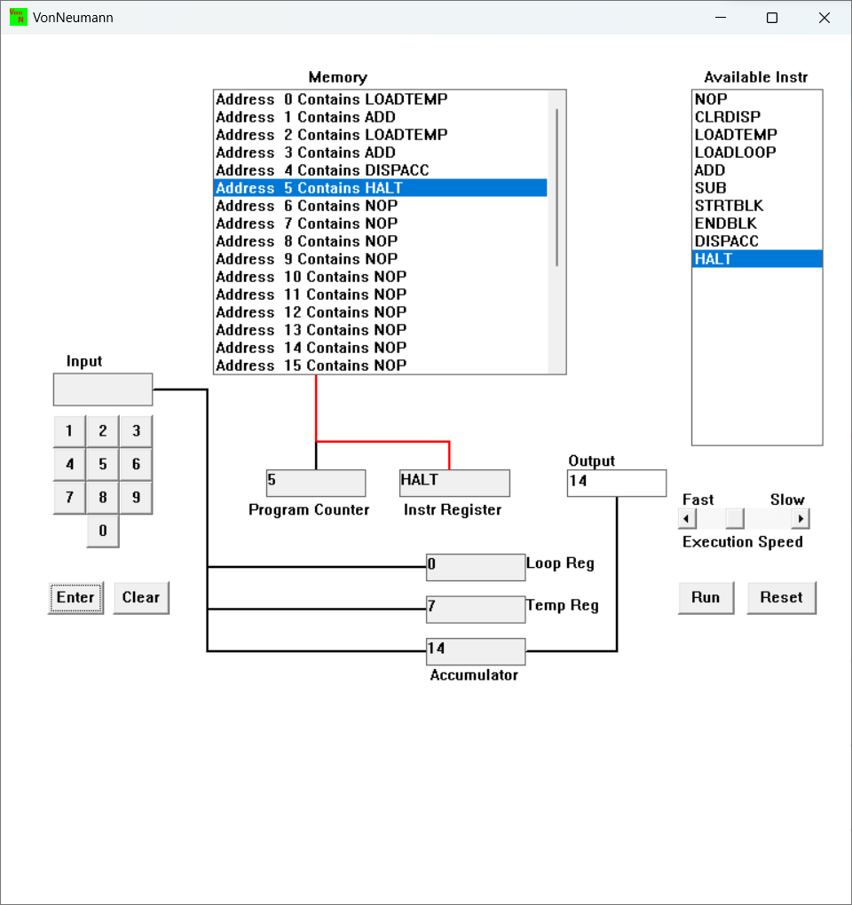

7 + 7 = 14

* 1. Write the program to add three numbers together and explain how does your code works?

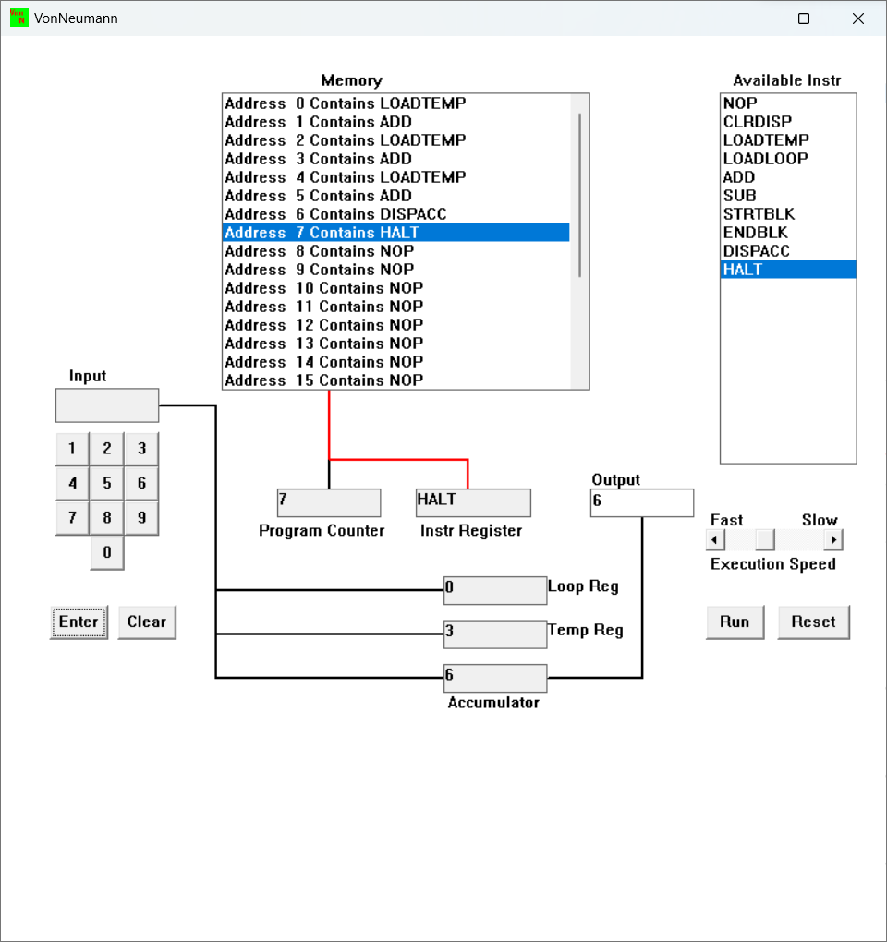

The code woks in the following proceedings:

At first, first data is loaded using code “loadtemp” and it is added to accumulator value and stored in it, and second data is loaded in the circuit, the second data is added to first value stored in the accumulator. Then the third value is loaded and added to the value in accumulator and displayed to the user at last. Then the program is halted/terminated.

* 1. Write the program to perform

7+3-9

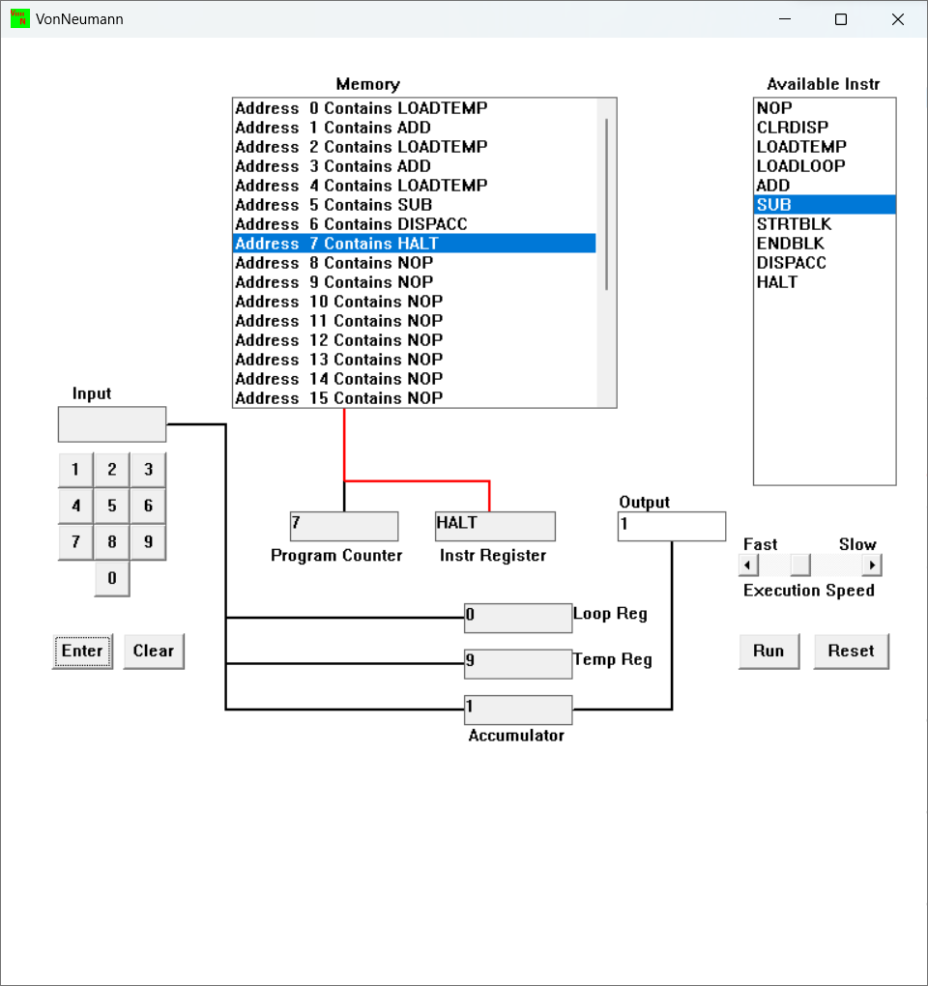

-9+3-7

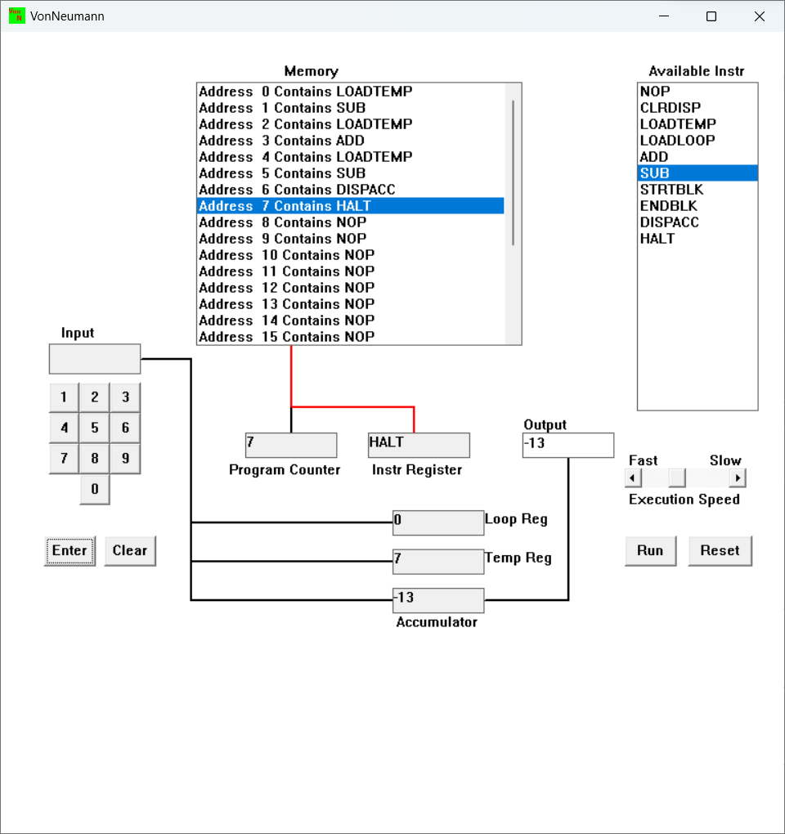

13-7+19

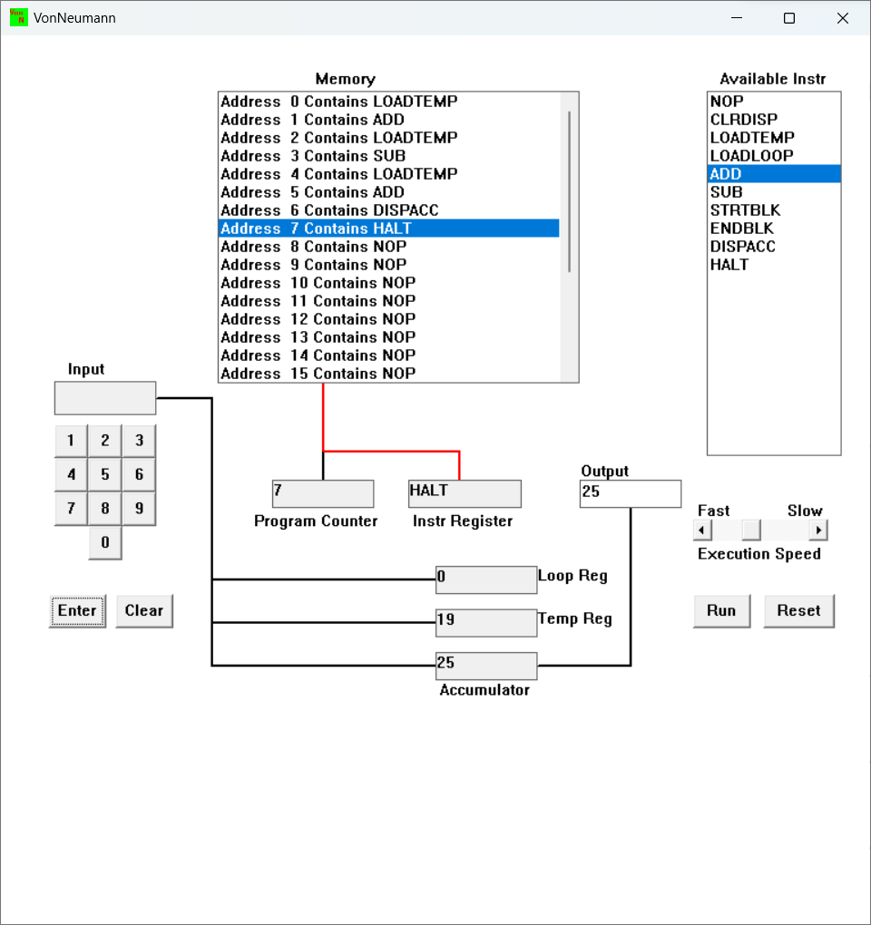

* 1. Write a program to perform

7+(7*3)

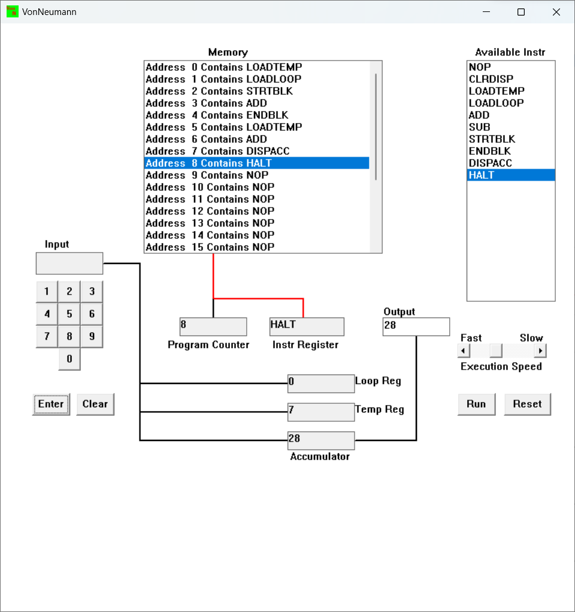

3+(3*7)

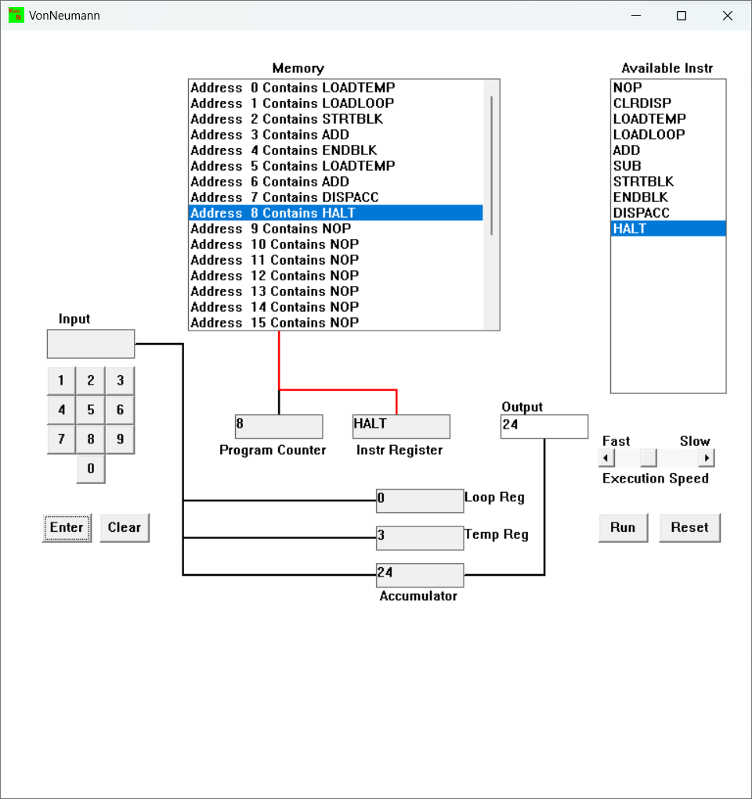

* 1. Write a program to add first 10 natural numbers.

